FULL SUMMER-INTERNSHIP

* Started from July 13th
* 3-weeks of coding bridge course
* Coding Bridge Course

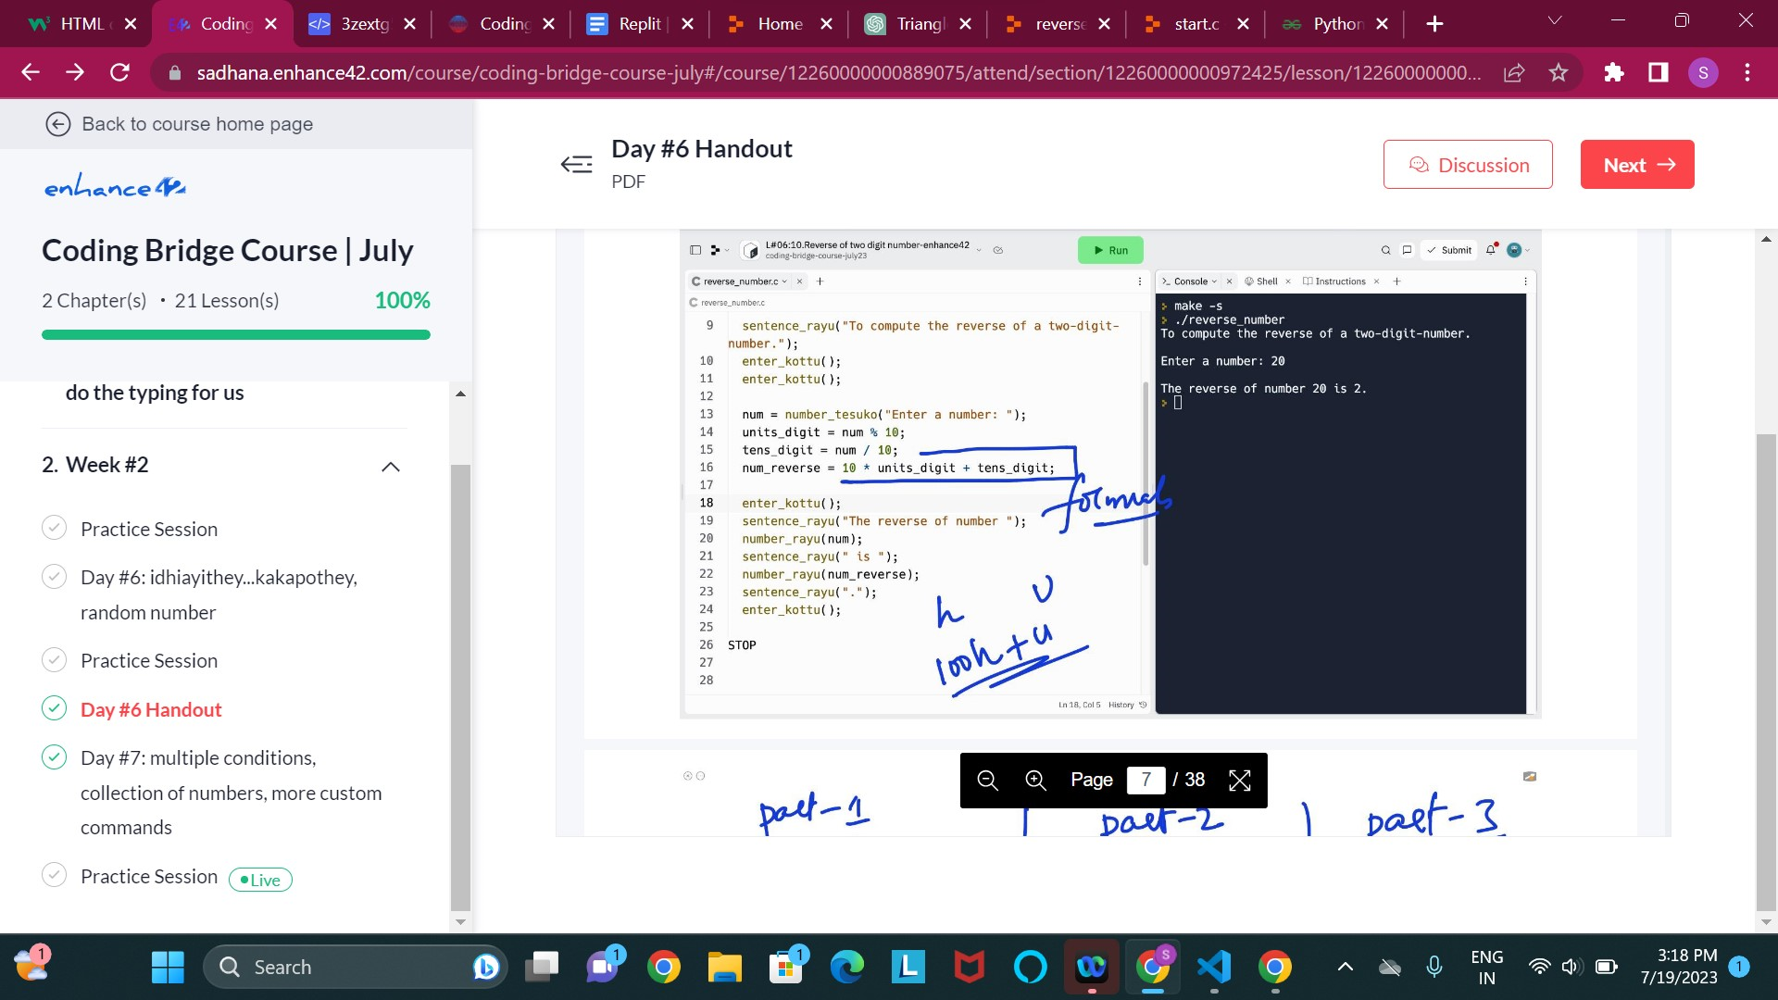

August:

Week-1:

* How to download vscode
* How to work with live server
* Starting the basics of html
* I will go through the youtube videos and w3 resource.

Week-2:

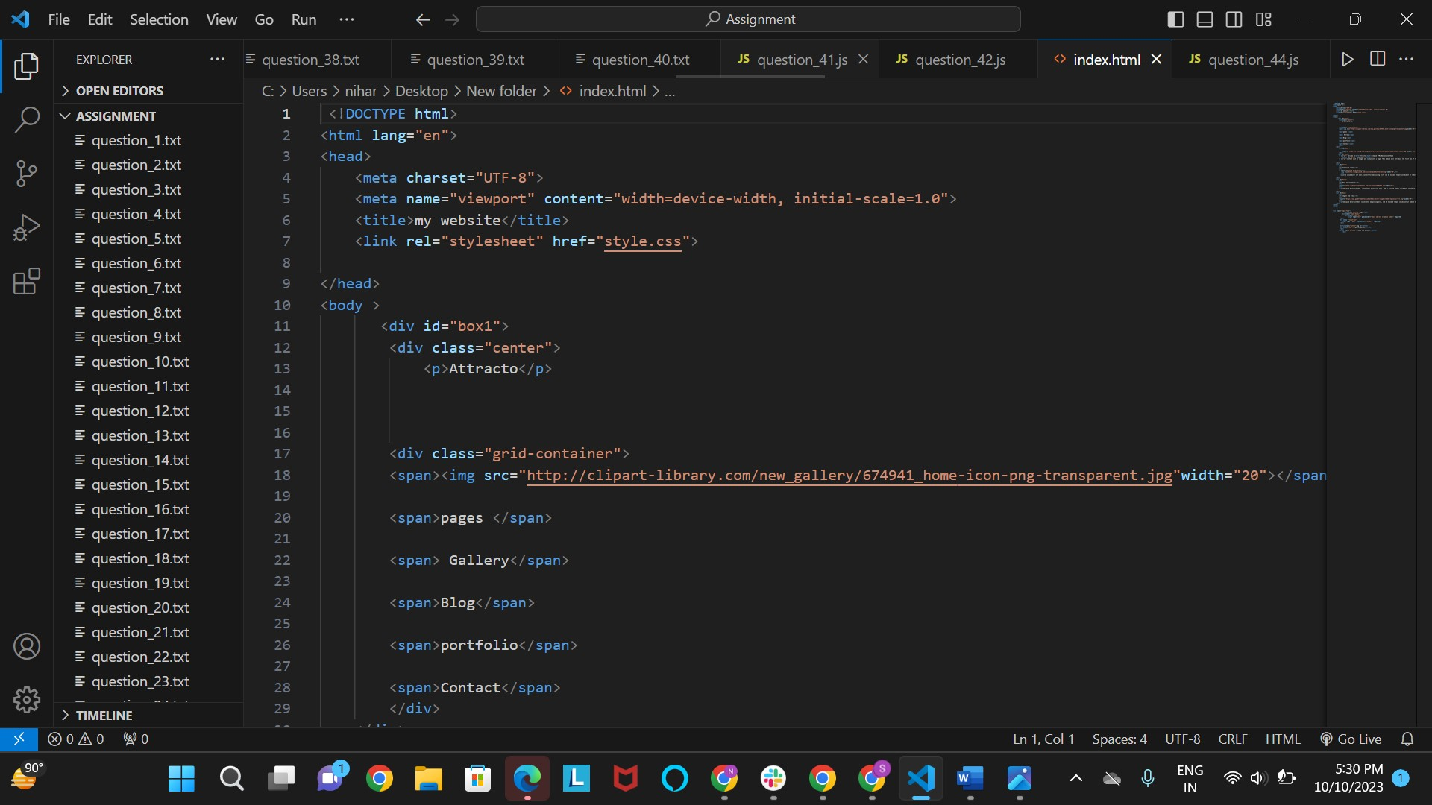

* Complete tutorial of html

Week-3:

started css basics

* inline css
* external css
* internal css
* css margin,border,backgrounds
* website layout
* Daily standup call

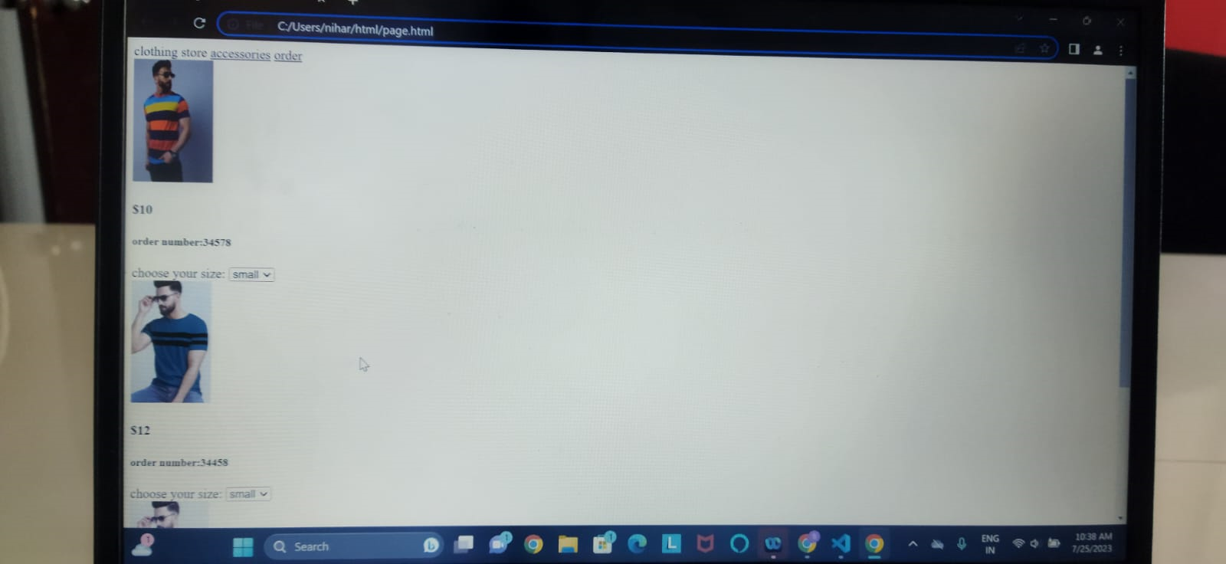

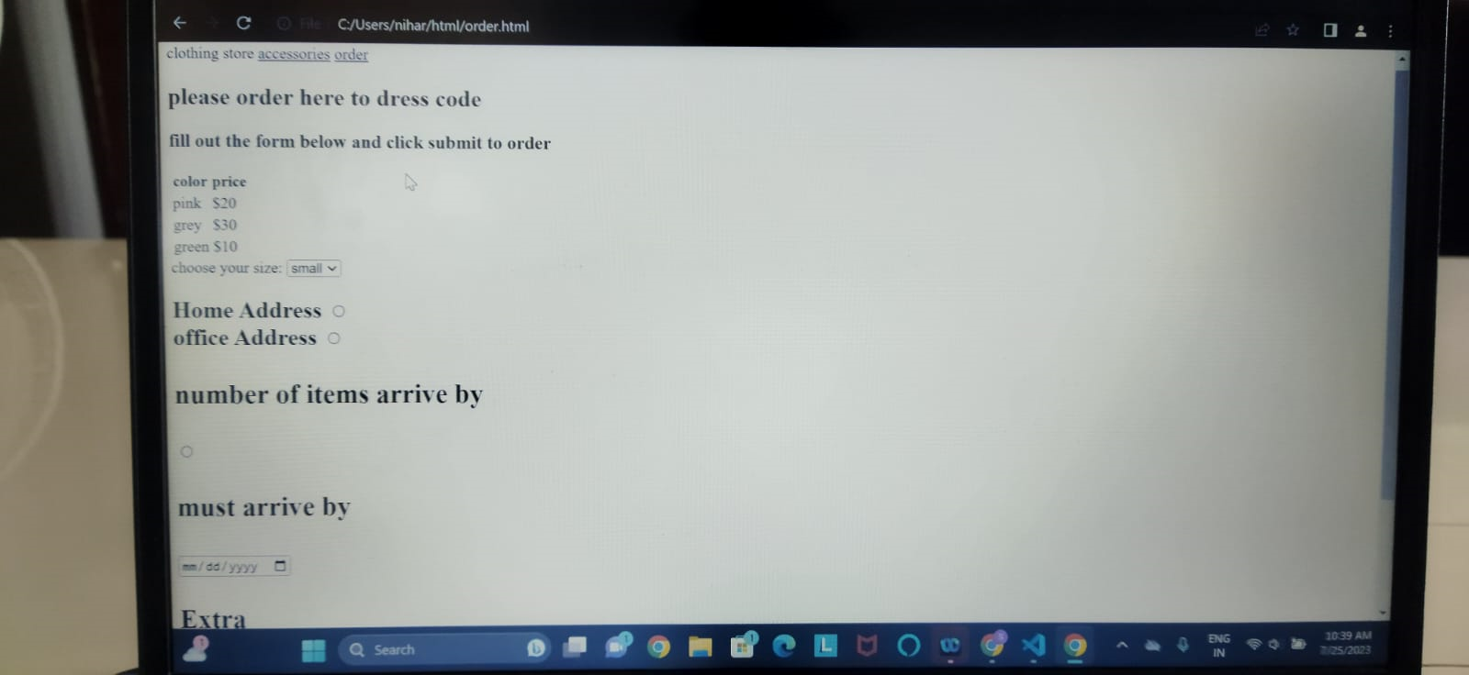

* learning company sales concept

week-4:

* css combinators
* css pseudo-class
* css icons
* Assignment:

Login -form

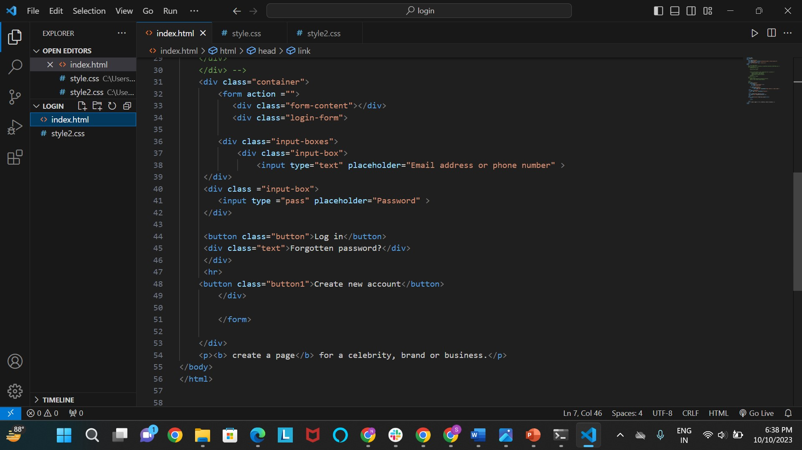

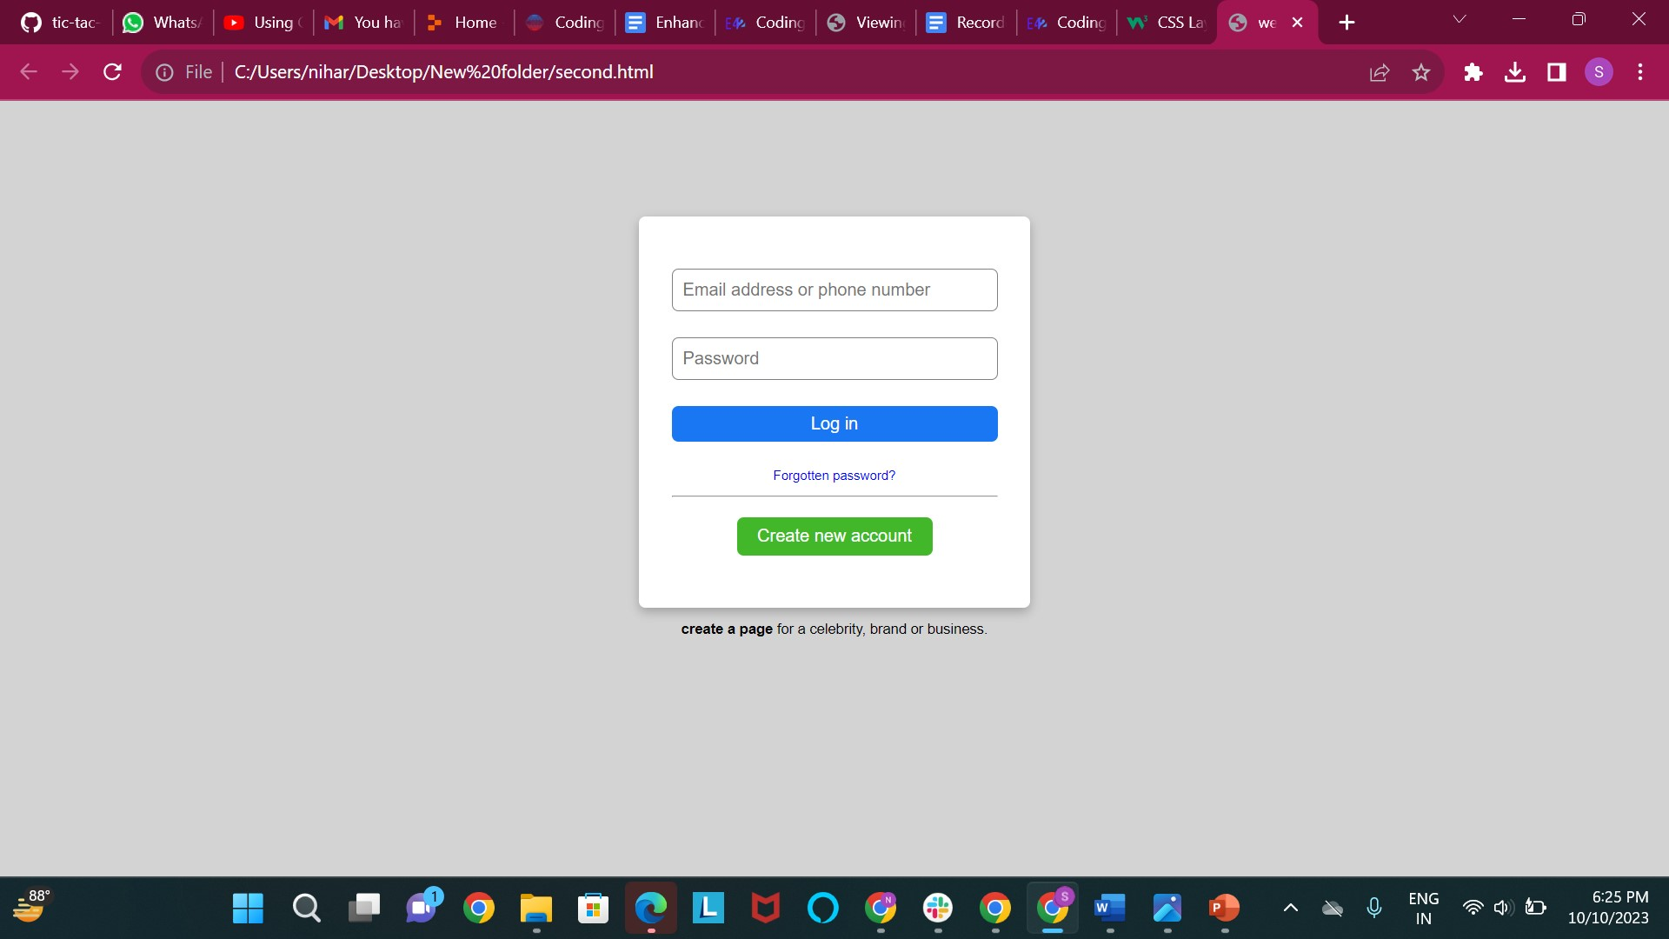

Week-5:

* Css z-index
* Css fonts
* Css gradients
* Css shadows
* Css buttons

Assignment:

Task to completed the navigator bar

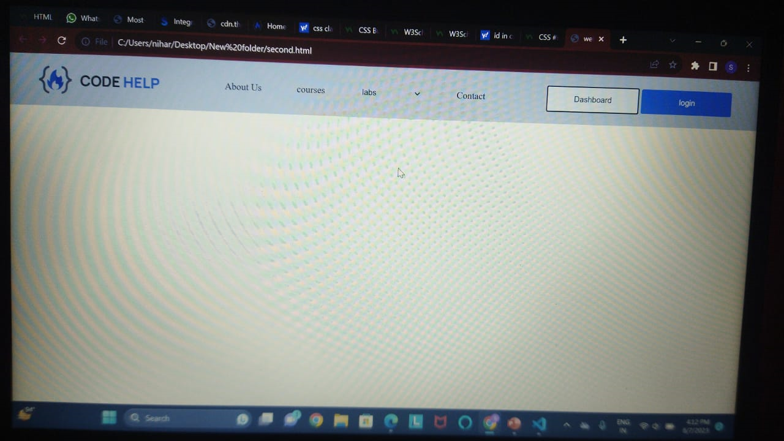

Week-6:

* Daily qualifying the sales for the company
* Css transitions
* Css Animations
* Css flexbox

Assignment:

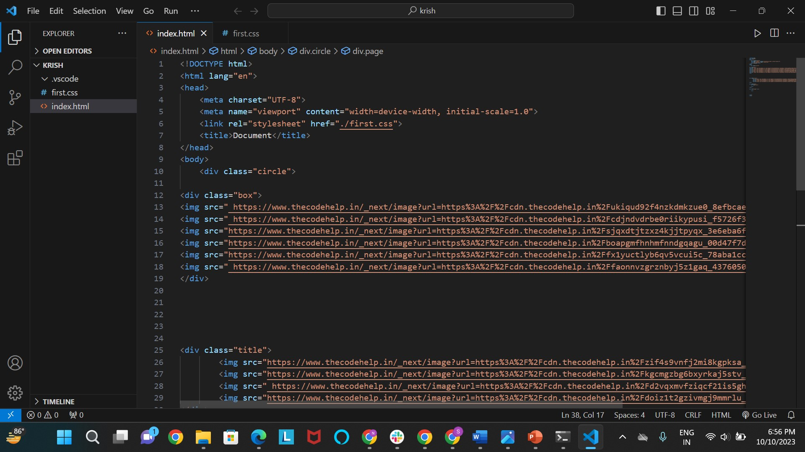

Output:

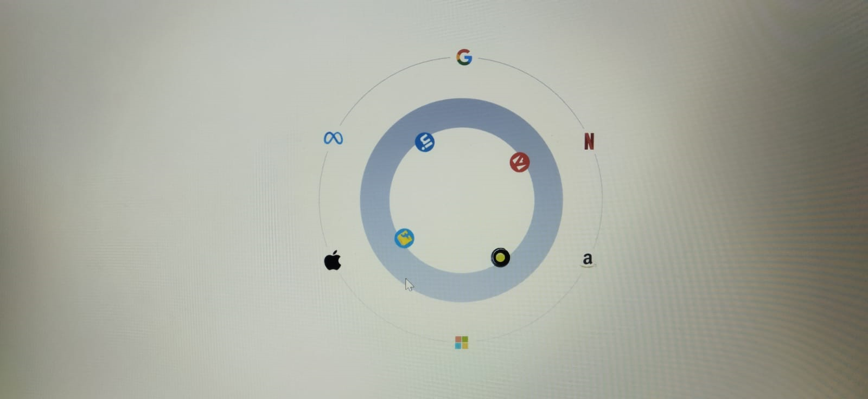

Week-7:

* Color properties
* Css grid
* Child properties

Assignment:

Todo-list

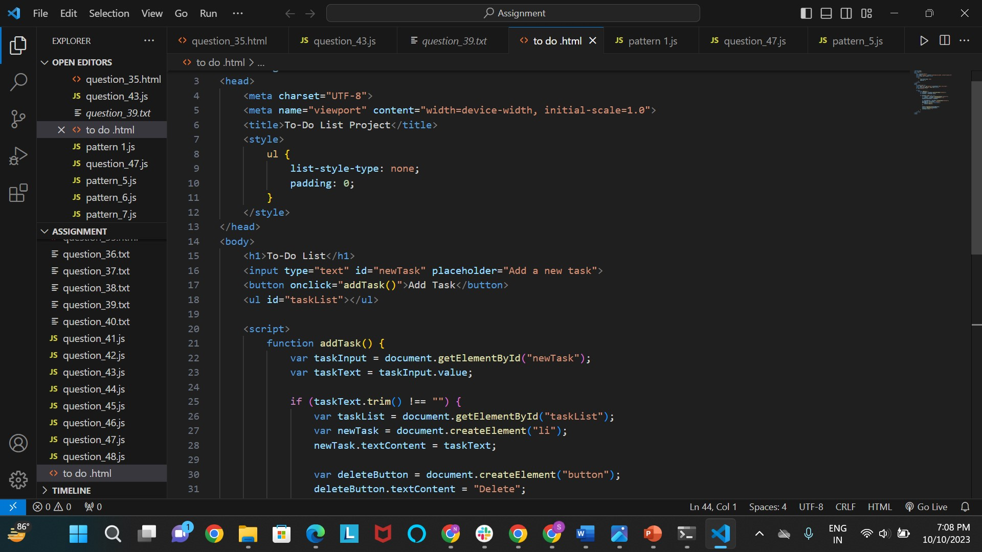

Output:

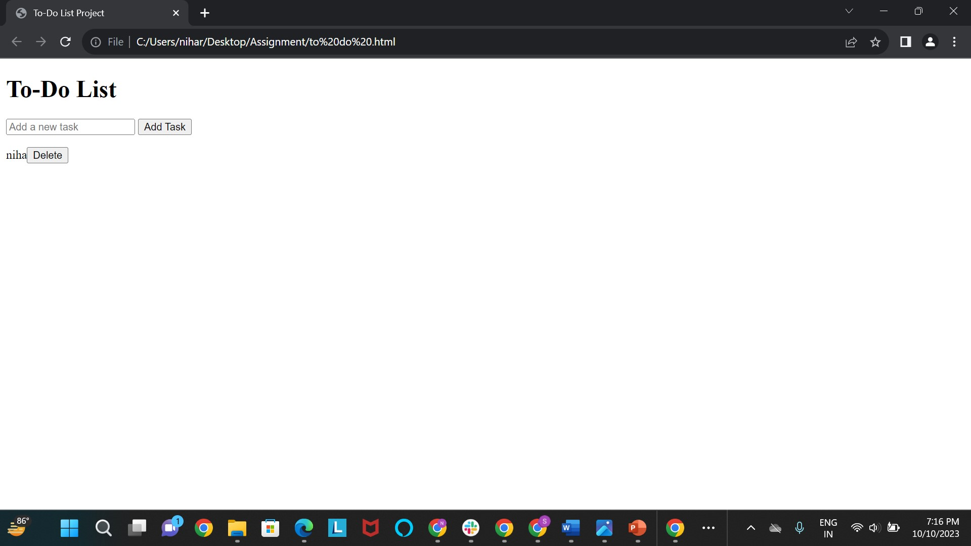

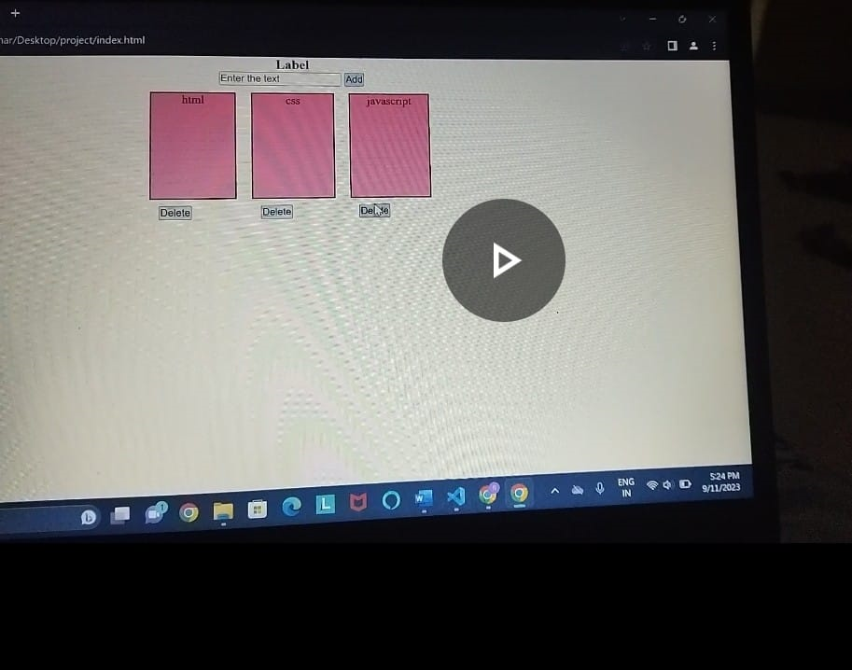

Week-8:

* Qualifying sales for freebird app
* Started javascript course
* 1. Introduction to JavaScript:
* Role of JavaScript in web development.
* 2. Setting Up:
* Integrating JavaScript into web pages.
* Basic structure of an HTML document.
* 3. Variables and Data Types:
* Declaring variables (var, let, const).
* Data types (strings, numbers, booleans, arrays, objects).

Conditional statements (if, else, else if).

* Functions,array and objects.
* Introduction to the Document Object Model (DOM).

Assignment:

Given 48 questions:

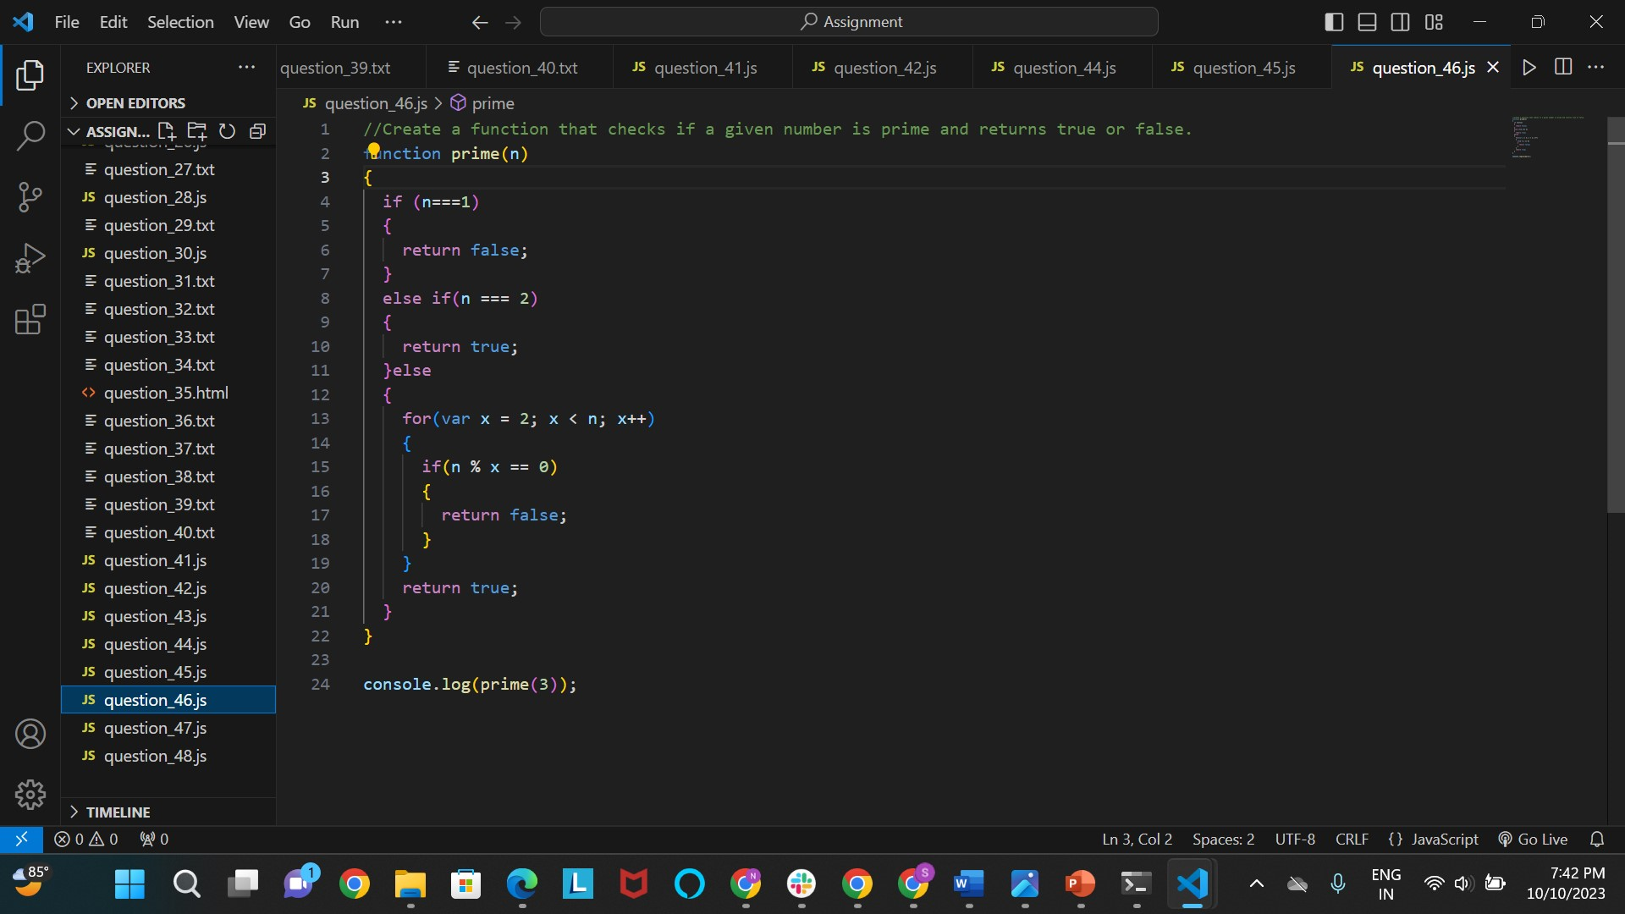

Week-9:

* DOM Manipulation
* Qualifying the sales
* Event listeners and handling.

Assignment:

Tic-Tac-Toe game:

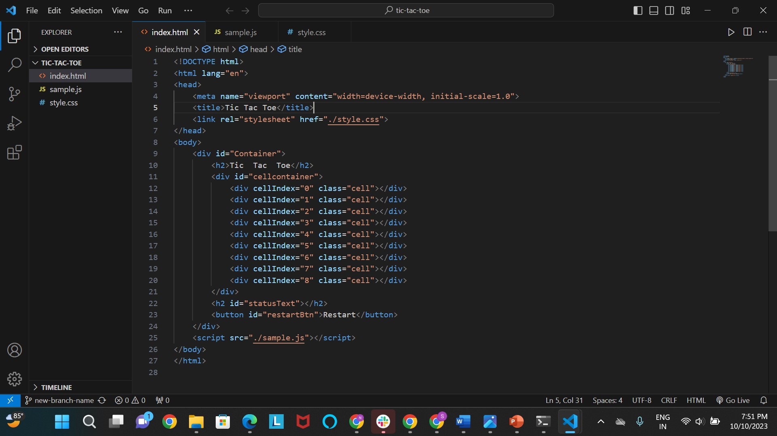

output: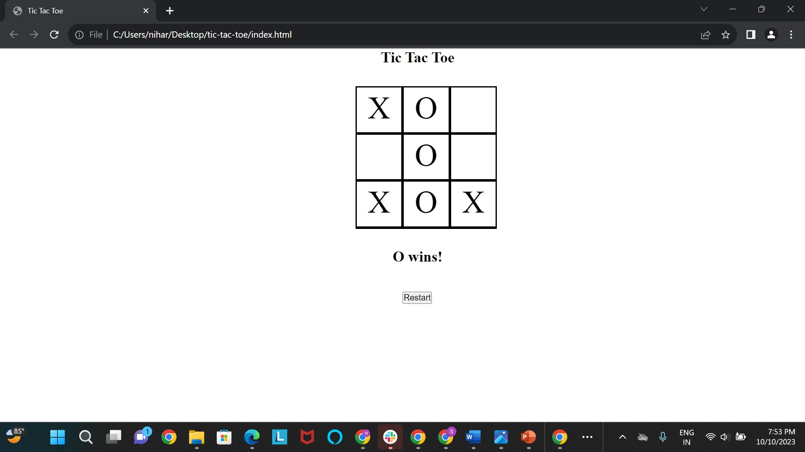 Week-10:

* Started react basics
* Introduction to React
* Jsx
* Styled components
* Go through with w3 resources and videos
* And Next 2 weeks attending clg training and drives.

Week-13:

* Started react and revise the topics.
* Create github account and create clone repository.
* Using git through visual studio code.

